DEPLOY THE APPLICATION USING JENKINS

STEP1: login jenkins and install the plugins.

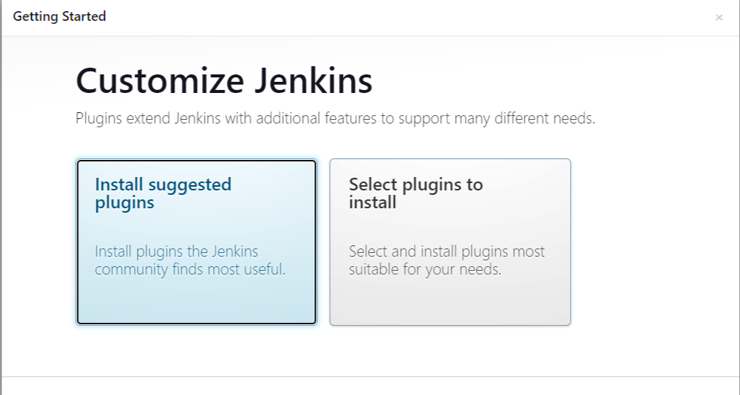

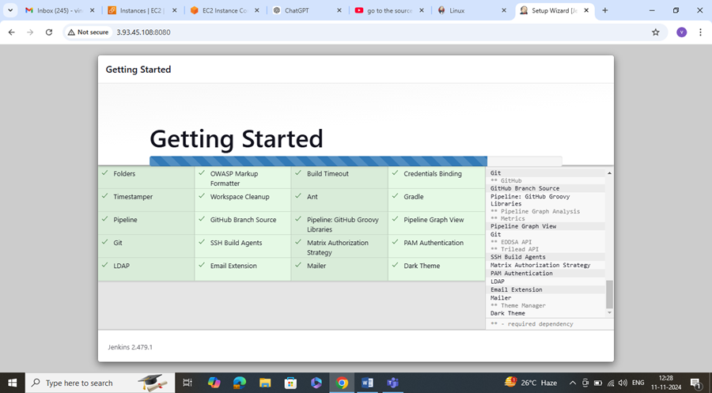

Step2: using git url deploy the application using jenkins

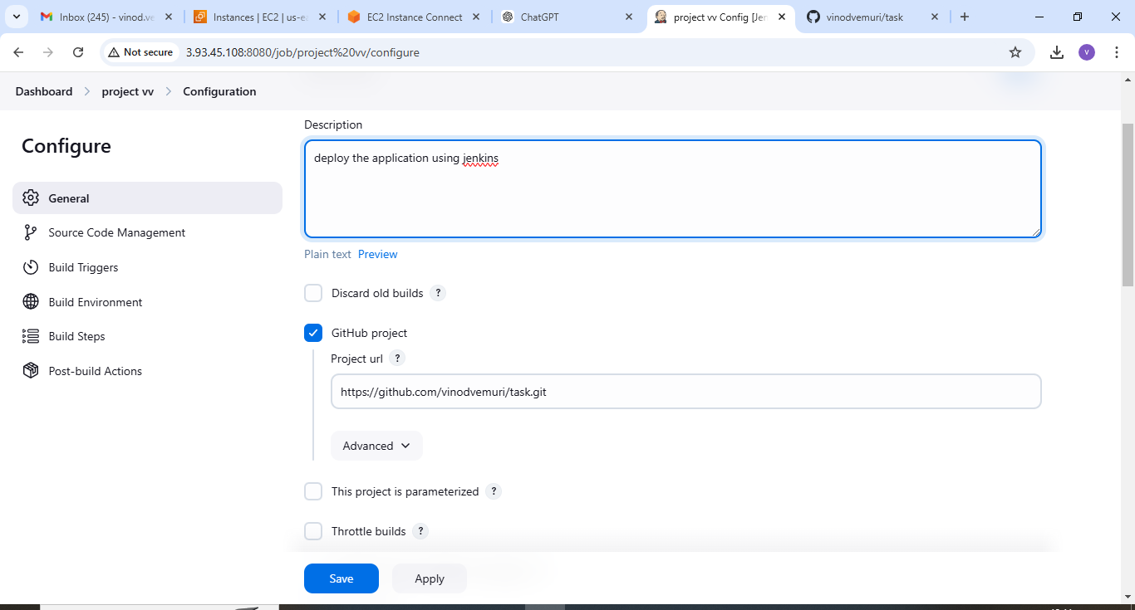

* Connect to the Jenkins server and install the java and Jenkins.
* And now go to Log into the Jenkins dashboard and install the sonarqube scanner and docker to container plugin.
* Install availabe plugins like Artfactrs and deploy to container,sonarqube.

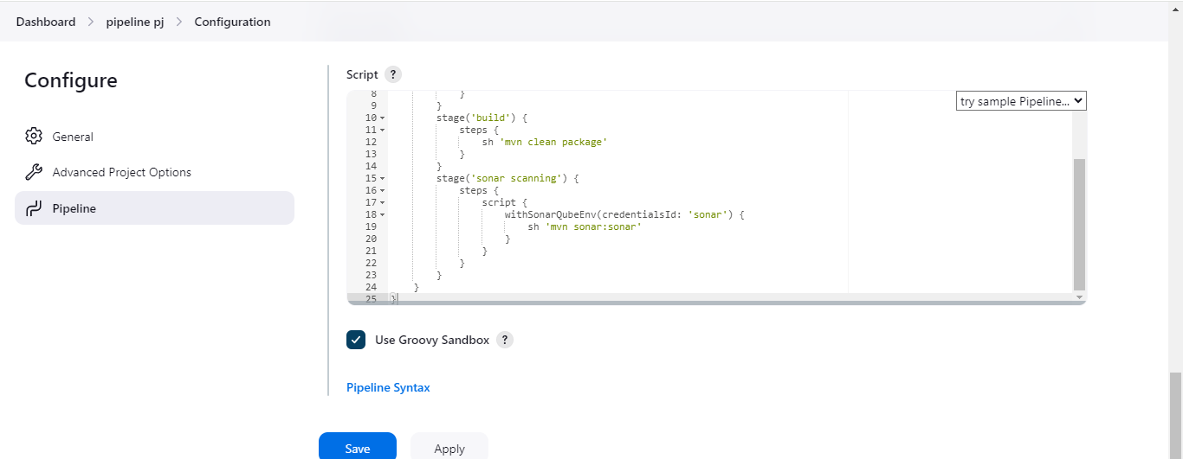

* Install the sonarqube on sonarqube server.

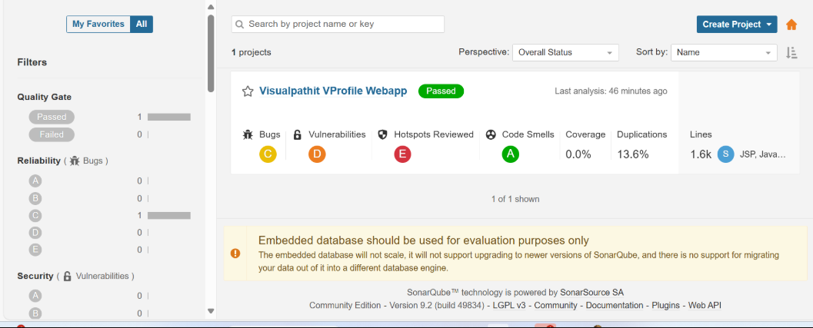

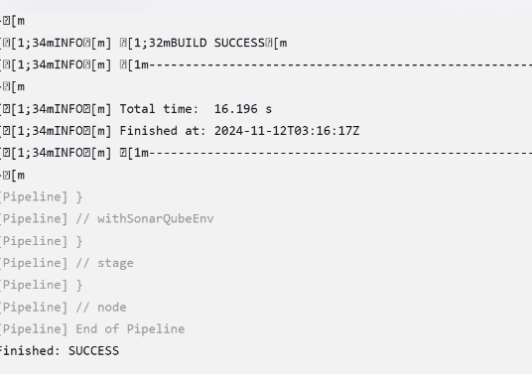

* Install the tomcat on tomcat server.
* Sign in the username and password based in tomcat

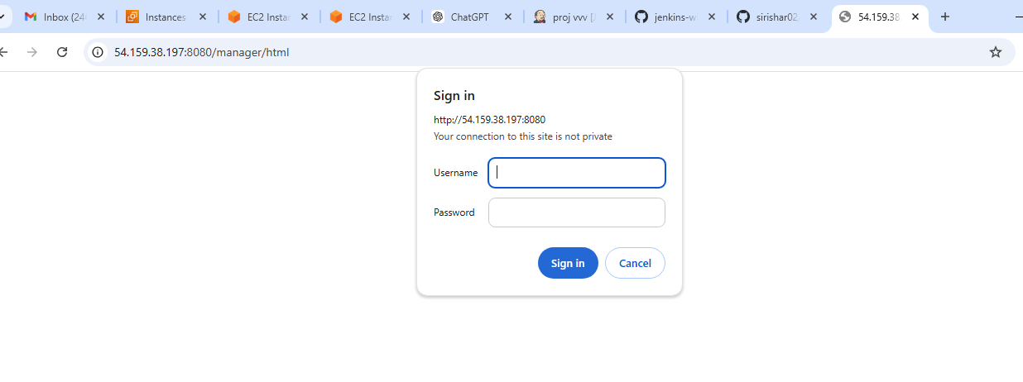

* In jenkins deploy the tomcat

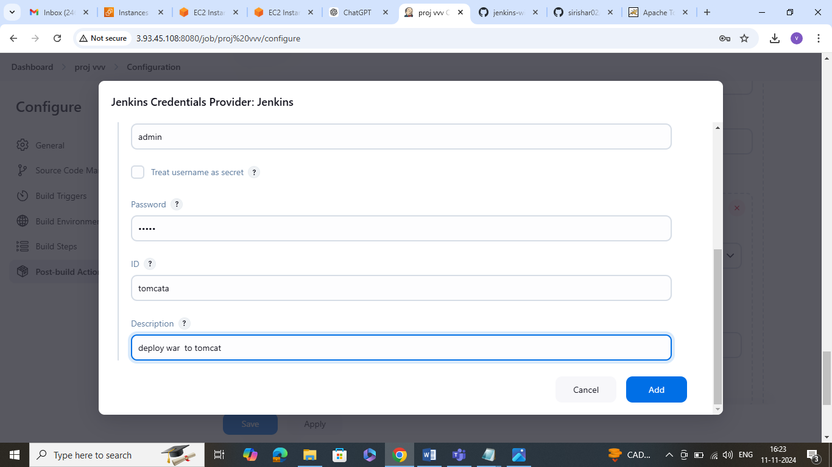

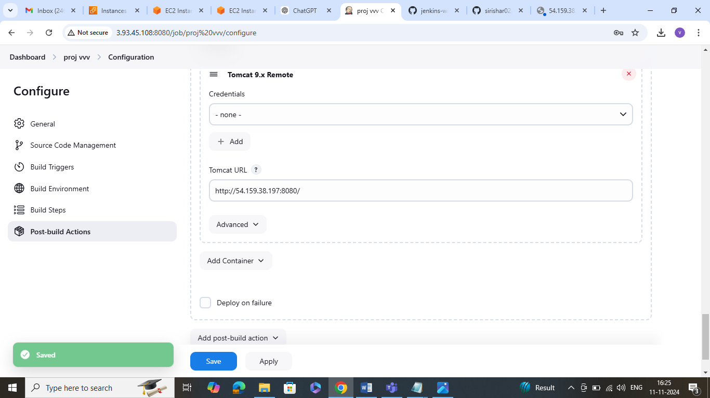

* Tomcat wed application manager.

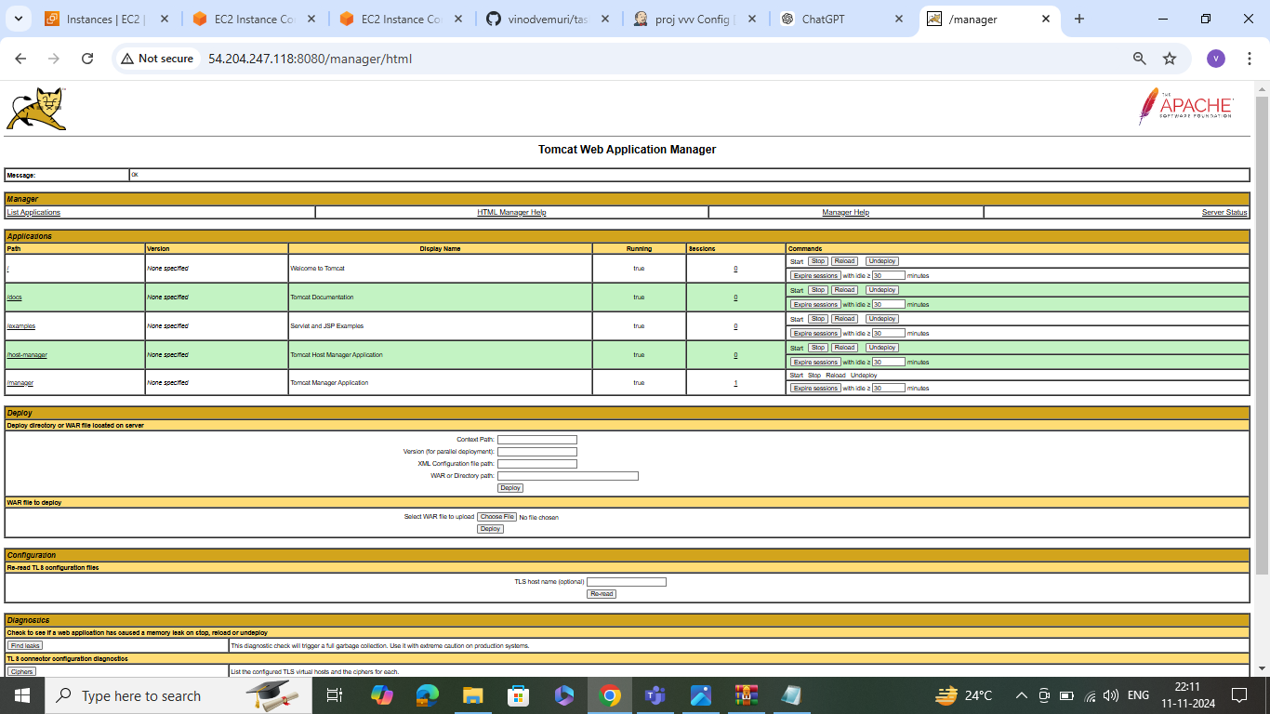

* Login to the sonatype nexus repository.

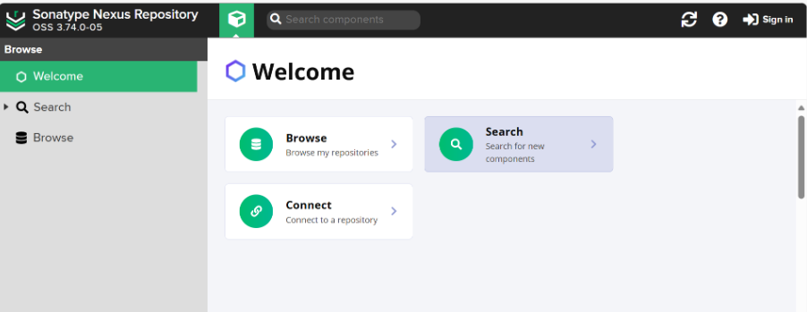

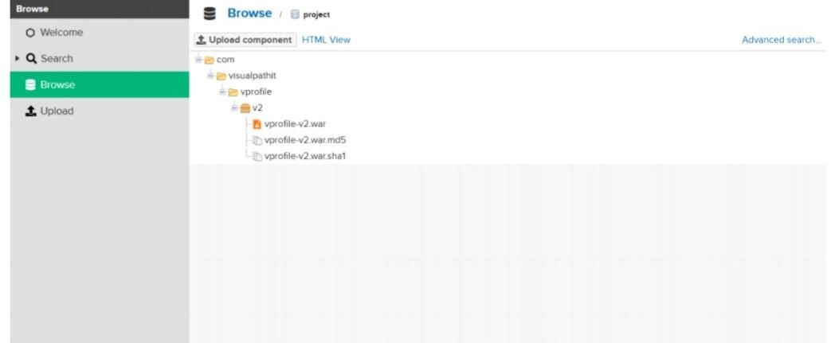

* Final out put

